Course Code: CSA1557

Course Name: Cloud Computing and Big Data Analytics

S.Prakul 192210073

1) Create a simple cloud software application for Flight Reservation System using any Cloud Service Provider to demonstrate SaaS include the necessary fields such as one way, round trip, From, to, Departure, Departure, Travelers & Class, Fare Type, International and Domestic Flights etc.

AIM: To create a simple cloud software application for flight reservation system using any cloud service provider to demonstrate saas.

PROCEDURE:

Step1: Go to zoho.com.

Step 2: Log into the zoho.com.

Step 3: Select one application step.

Step4: Enter application name as flight reservation system.

Step 5: Created new application flight reservation system.

Step 6: Select one form

Step 7: The software has been created.

IMPLEMENTATION:

STEP1: GOTO ZOHO.COM

STEP 2: LOGINTOTHE ZOHO.COM

STEP 3: SELECT ONE APPLICATION

STEP 4: ENTER APPLICATION NAME

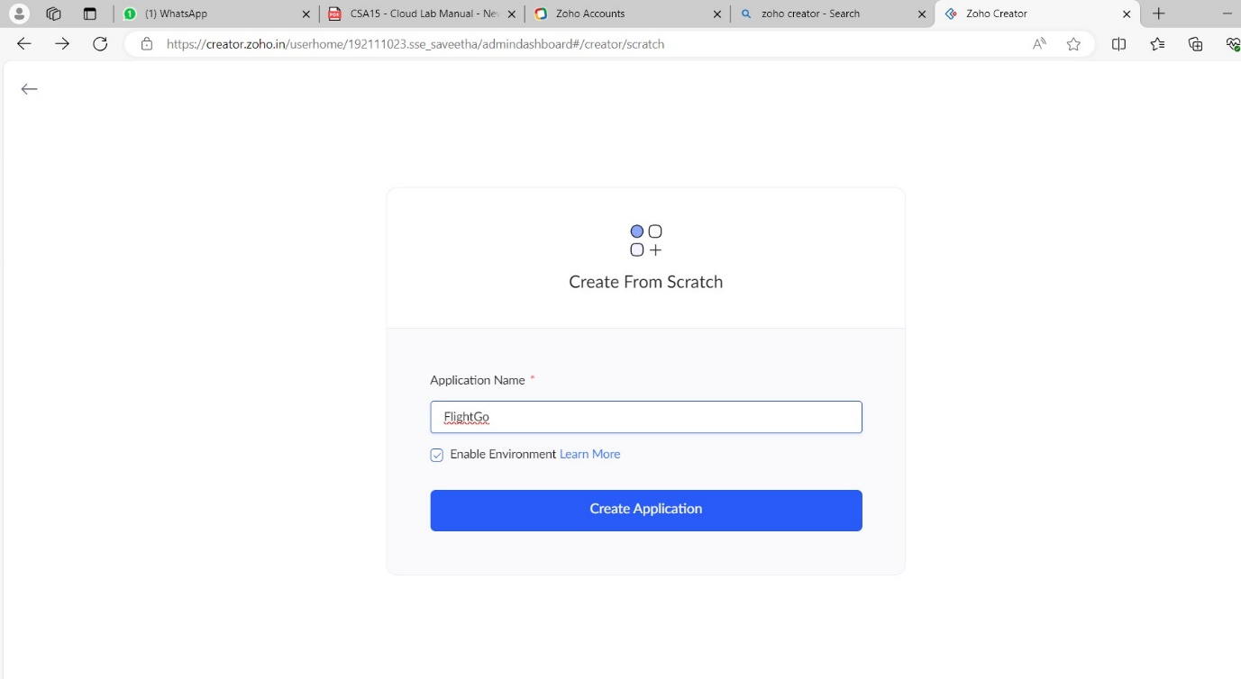

STEP 5: CREATED NEW APPLICATION

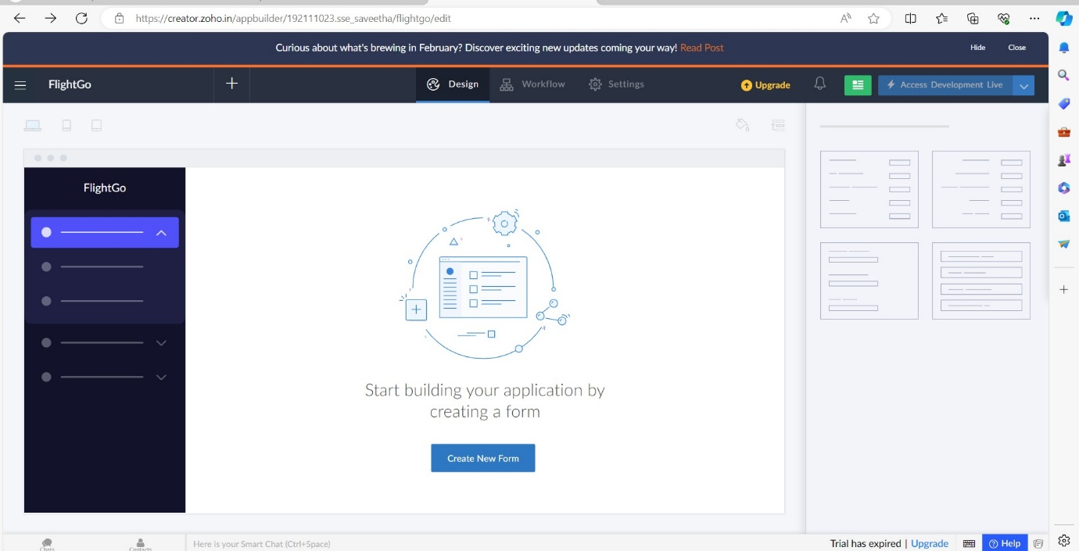

STEP 6: SELECT FROM STRATCH

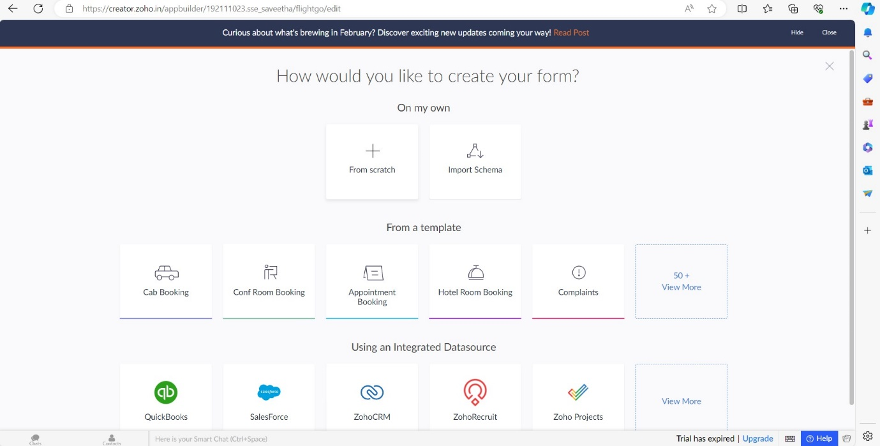

STEP 7: CREATE FORM AS LOGIN.

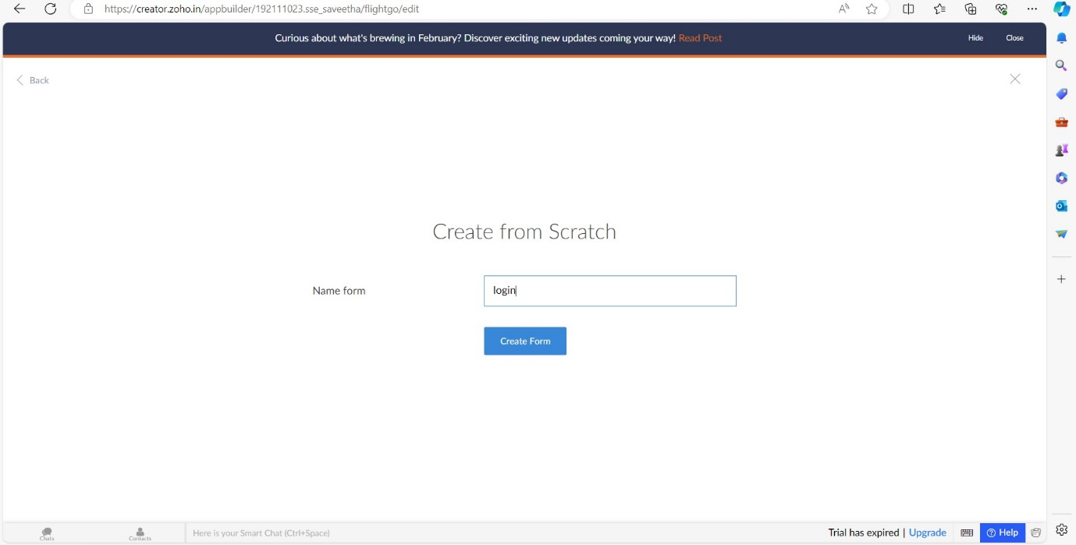

STEP 8: THE FORM HAS BEEN CREATED AS LOGIN AND CHOOSE THE FIELDS IN LOGIN PAGE

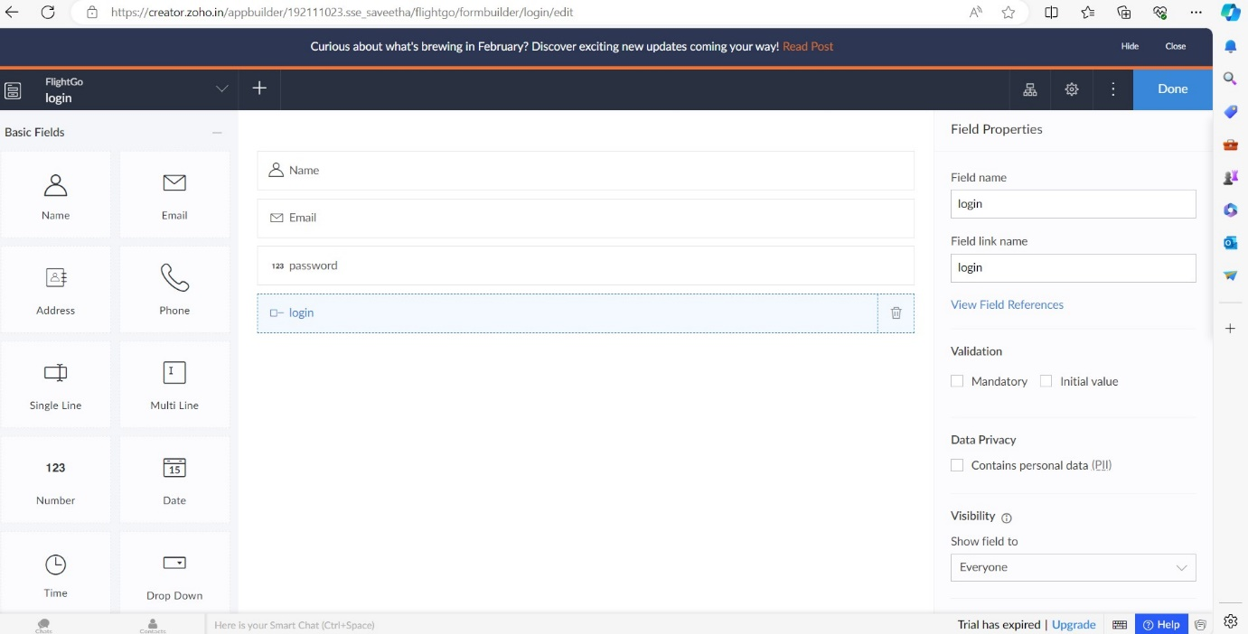

STEP 9: CLICK ACCESS DEVELOPMENT LIVE.

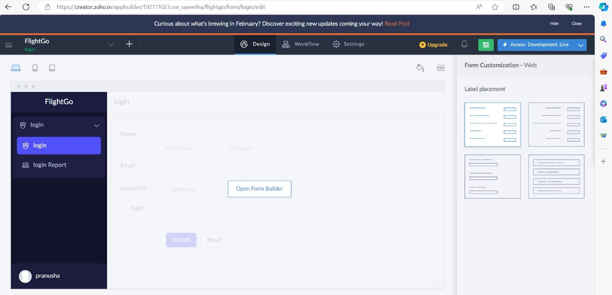

STEP 10: ENTER THE DETAILS TO LOGIN

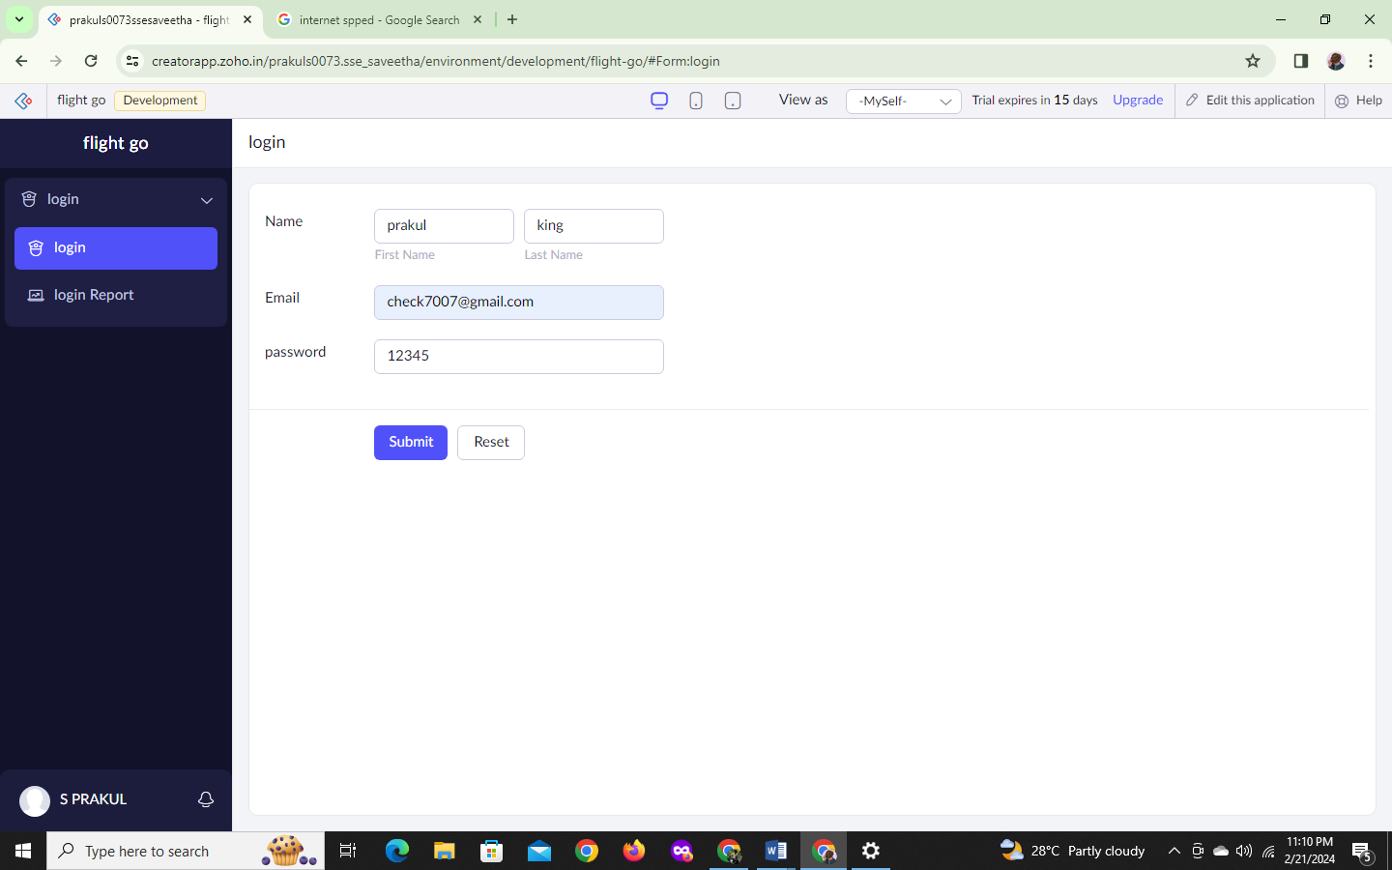

STEP 11:CLICK LOGIN REPORT ,THE REPORT HAS BEEN REGISTERED IN THE LOGIN REPORT.

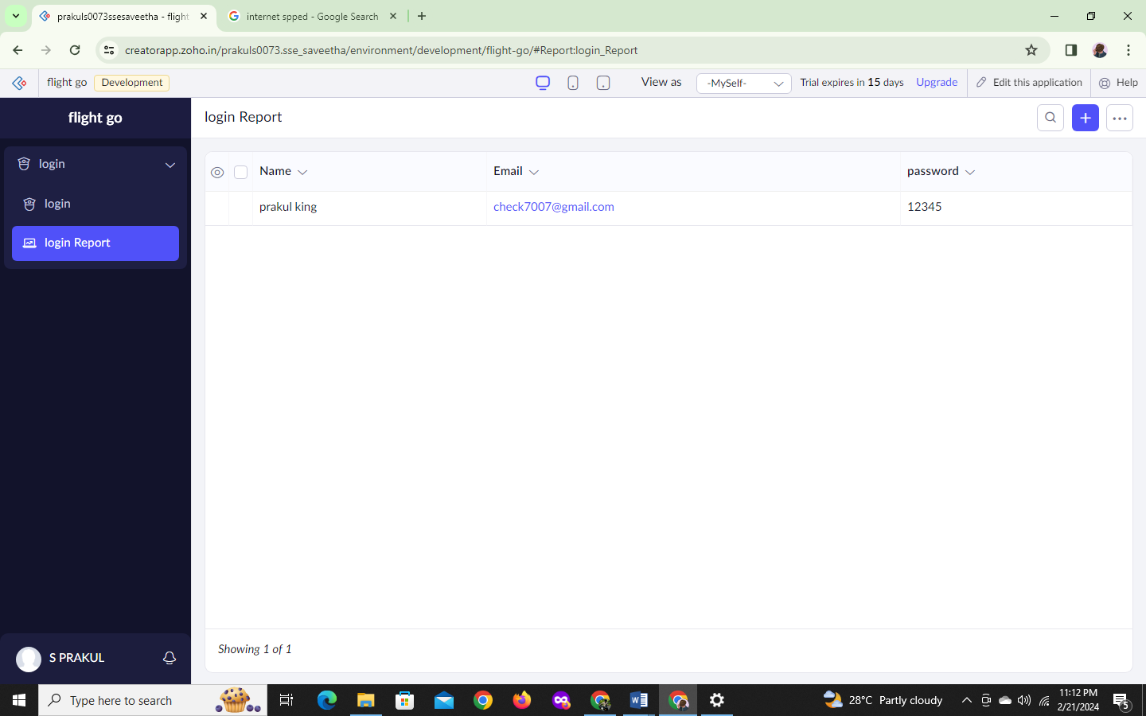

STEP 12: THEN CREATE ANOTHER NEW COMPONENT.

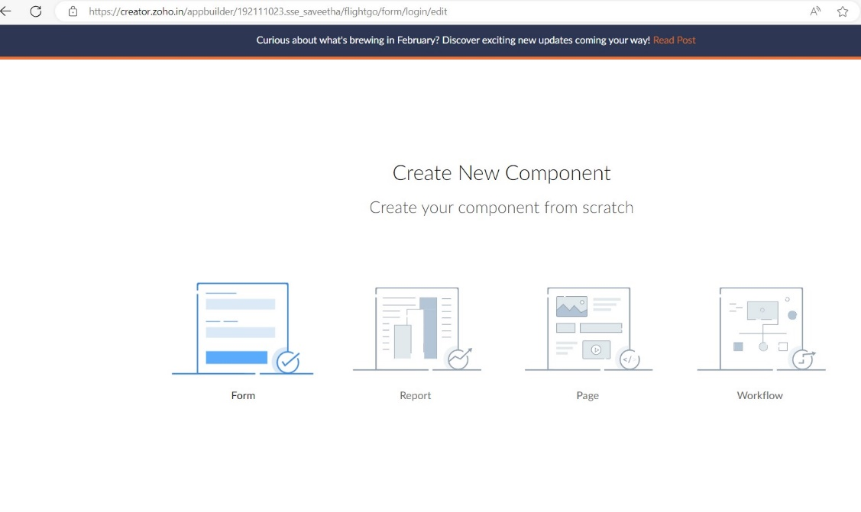

STEP 13: CLICK FROM SCRATCH

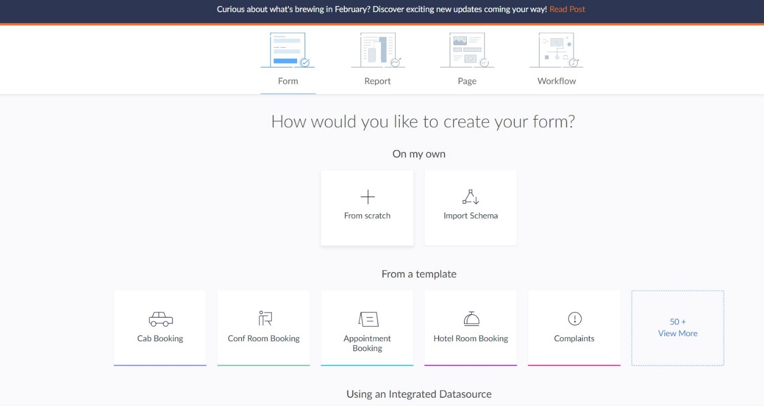

STEP 14: CREATE FORM AS FLIGHT ARRIVAL_DEPARTURE .

THE FORM HAS BEEN CREATED AS FLIGHT ARRIVAL_DEPARTURE AND CHOOSE THE FIELDS IN FLIGHT ARRIVAL_DEPARTURE PAGE.

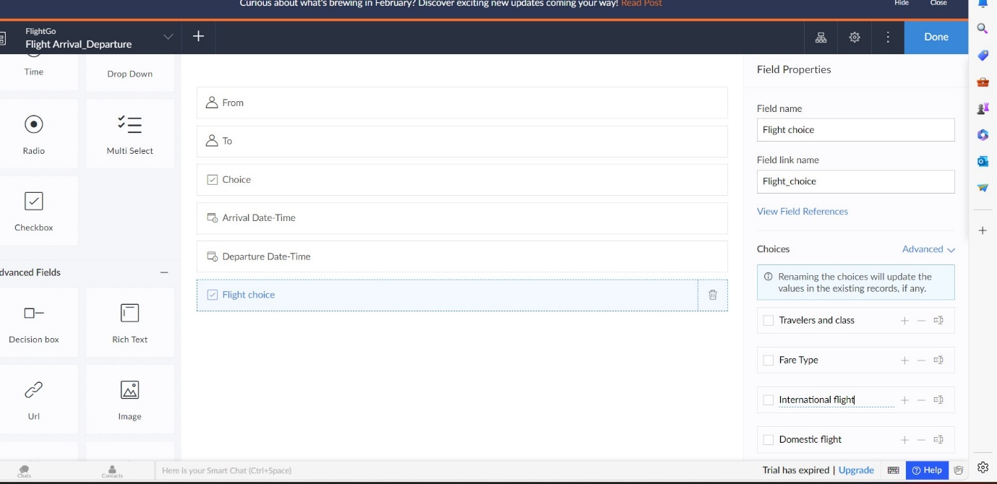

STEP 15: CLICK ACCESS DEVELOPMENT LIVE AND ENTER DETAILS.

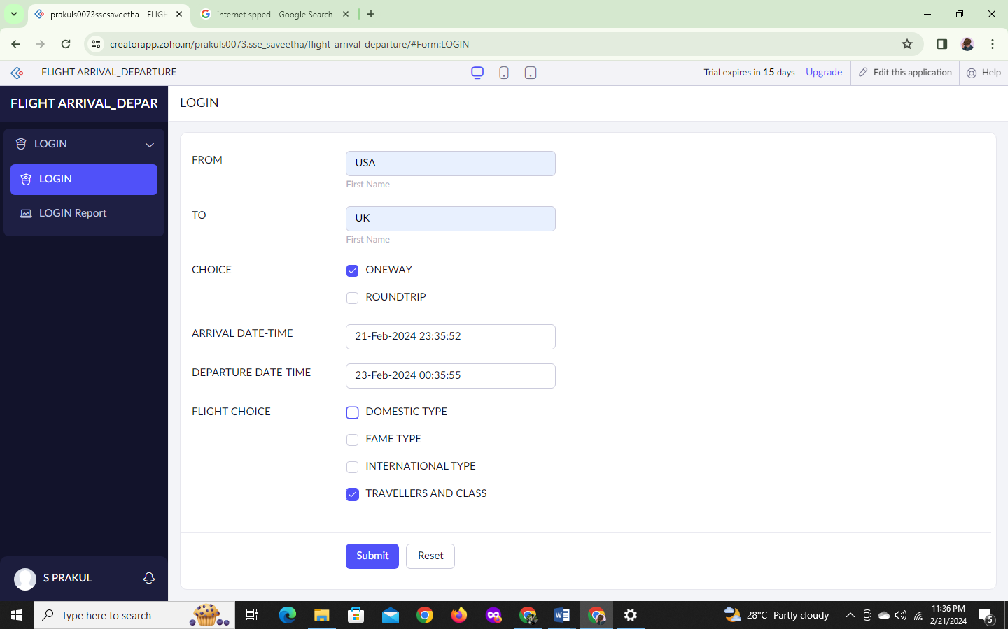

STEP 16: CLICK LOGIN REPORT. 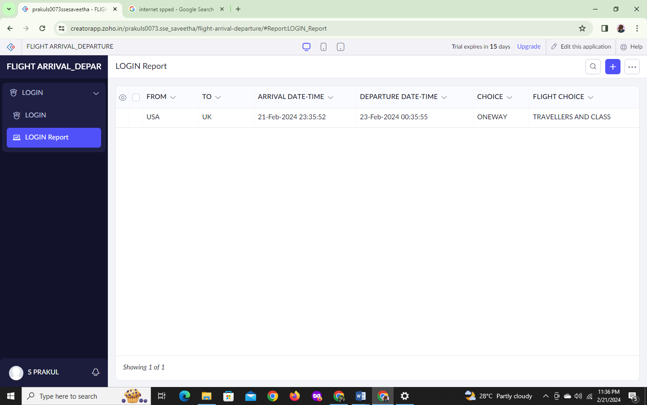

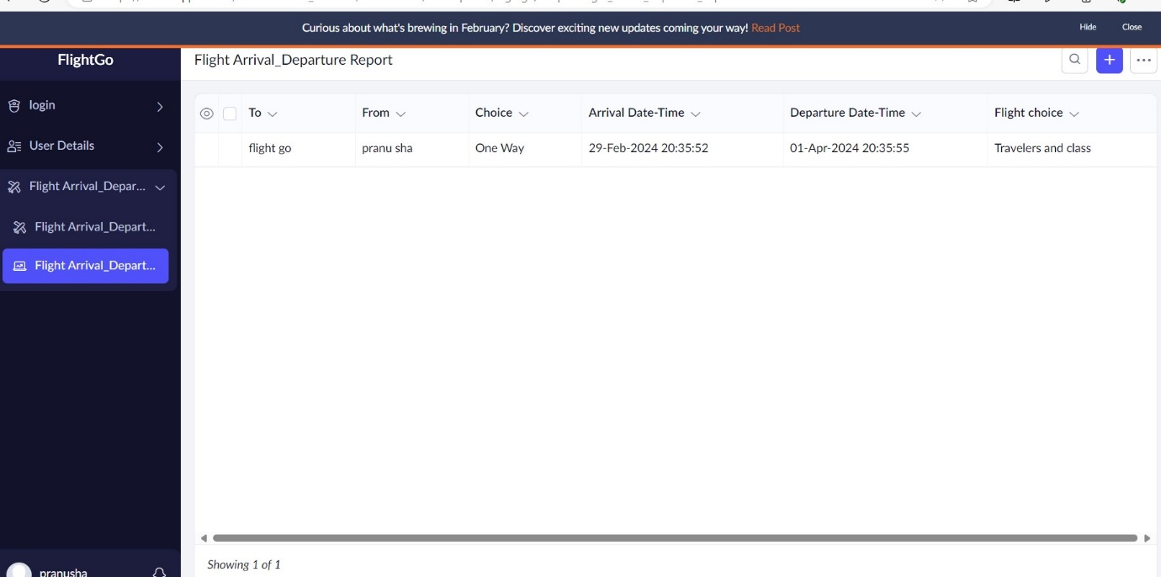

STEP 17:THE REPORT HAS BEEN REGISTERED.